Evaluation: Random Forest
Accuracy: 0.9692
Precision: 0.9691947945902039
Recall: 0.9692
F1 Score: 0.9691153731540691
Jaccard Index: 0.9403356719673372
Matthews CorrCoef: 0.9615405778685971
Cohen’s Kappa: 0.9615
Specificity: 0.9923
AUC: 0.9980644999999999
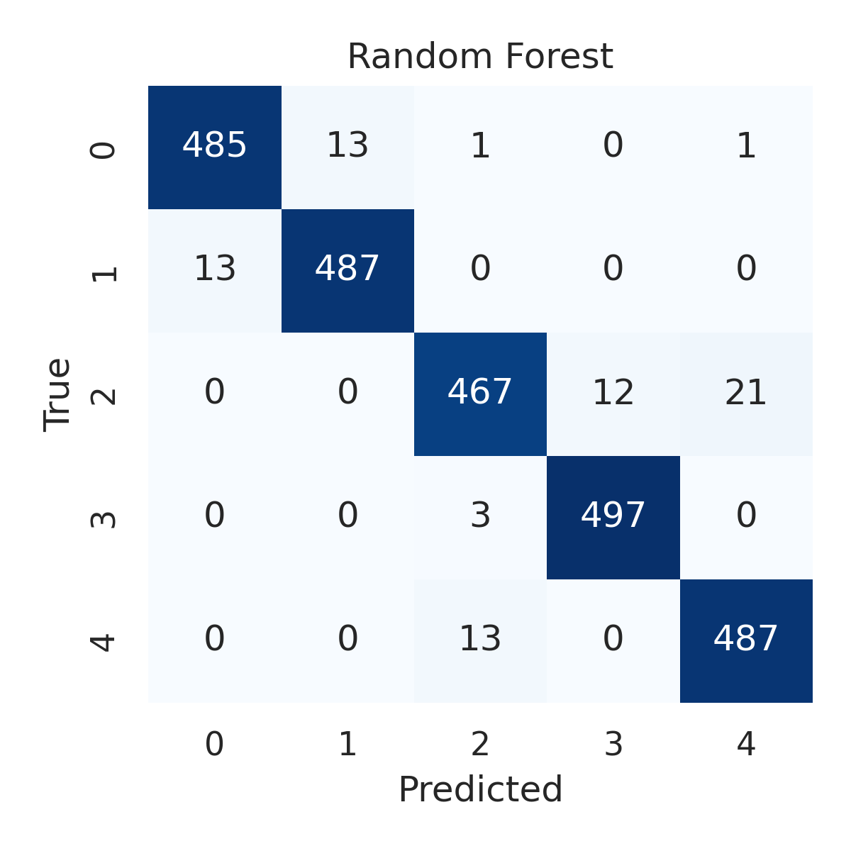

Combined ROC Curves
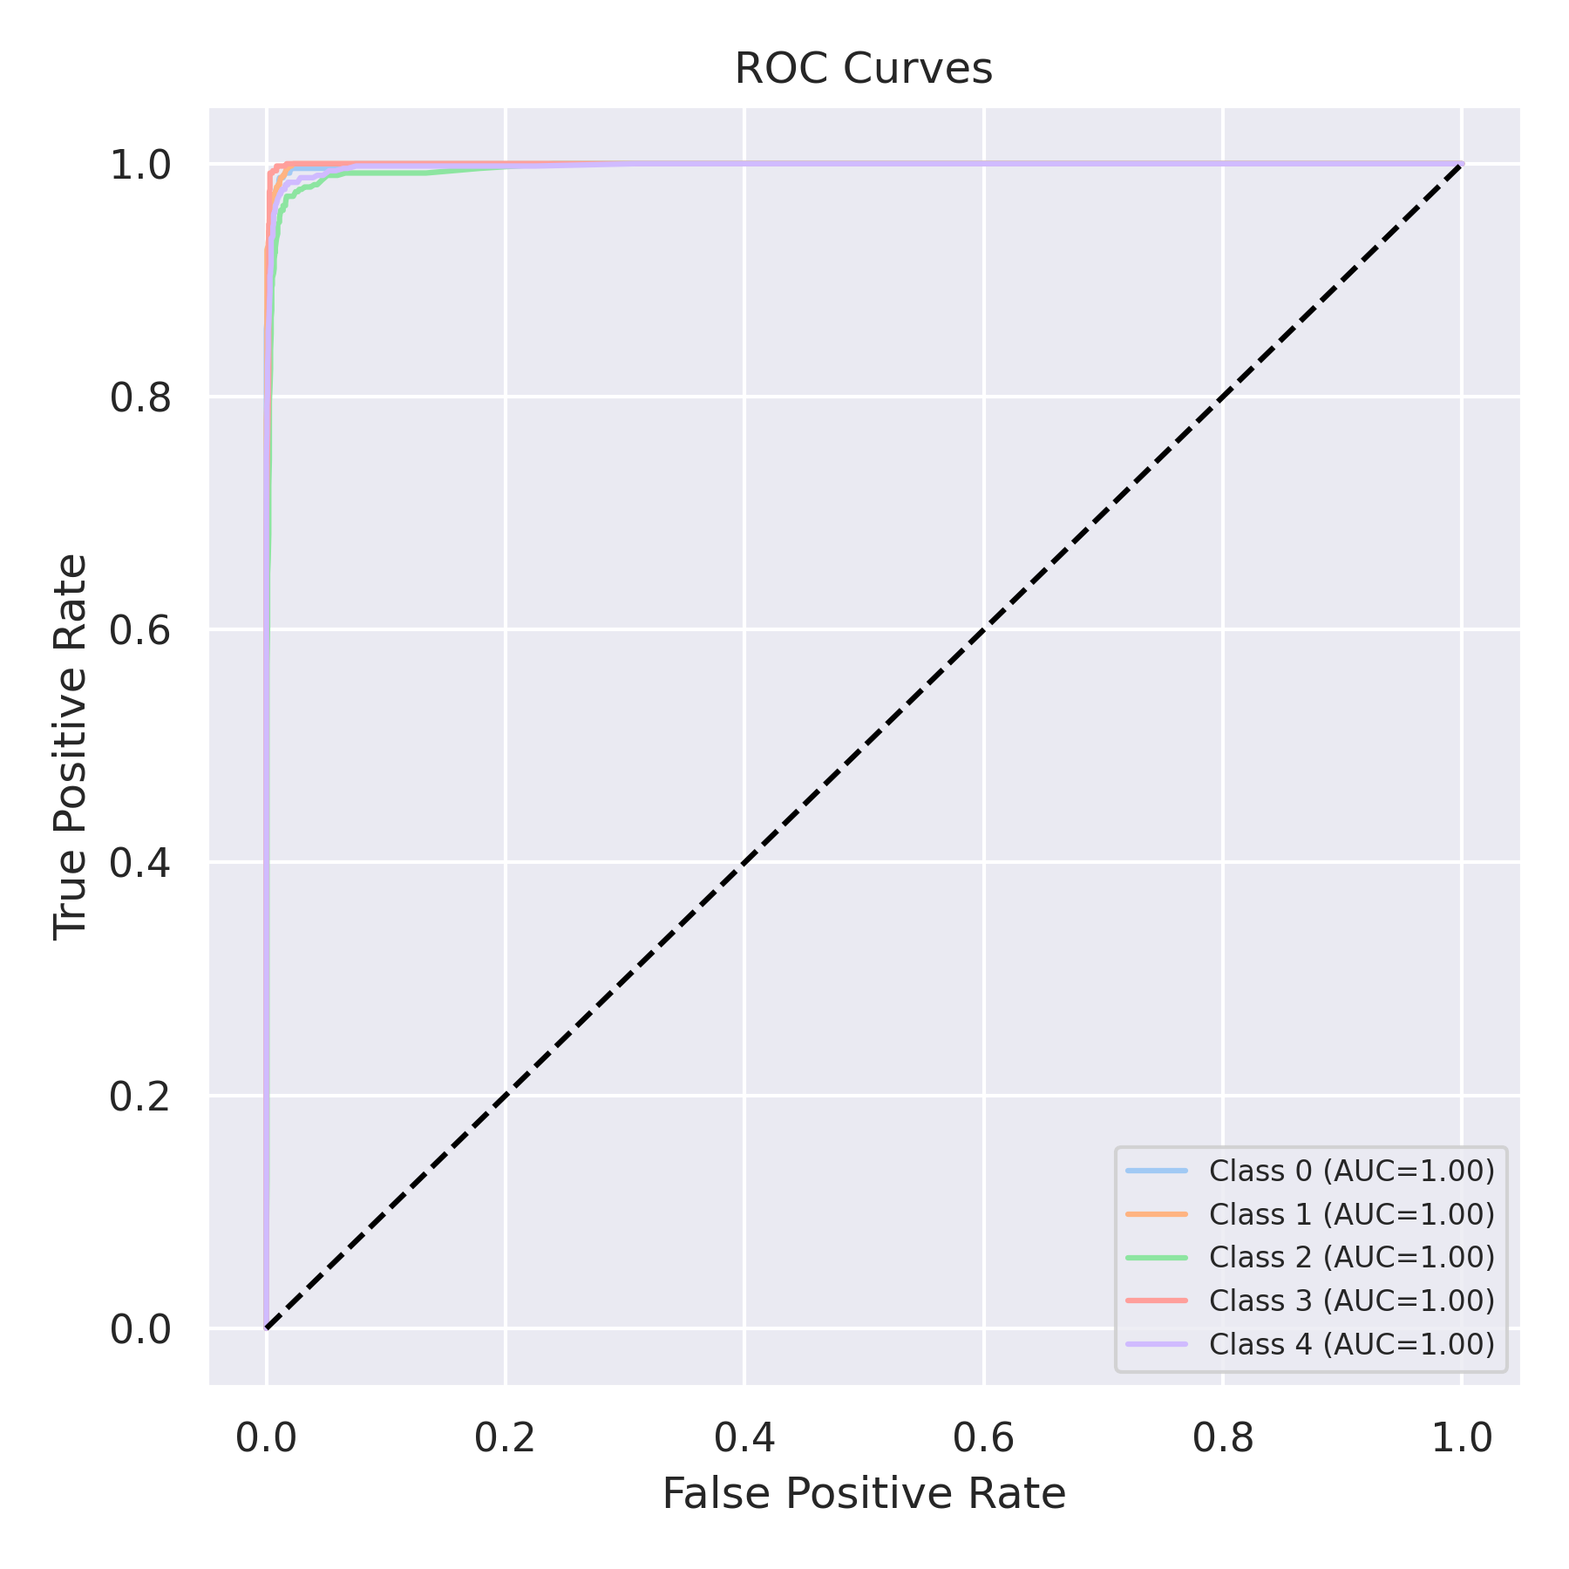

Evaluation: K-Nearest Neighbors
Accuracy: 0.884
Precision: 0.8867695379392415
Recall: 0.884
F1 Score: 0.8829683377576676
Jaccard Index: 0.7919280390170844
Matthews CorrCoef: 0.8561133287938546
Cohen’s Kappa: 0.855
Specificity: 0.9710000000000001
AUC: 0.9796775
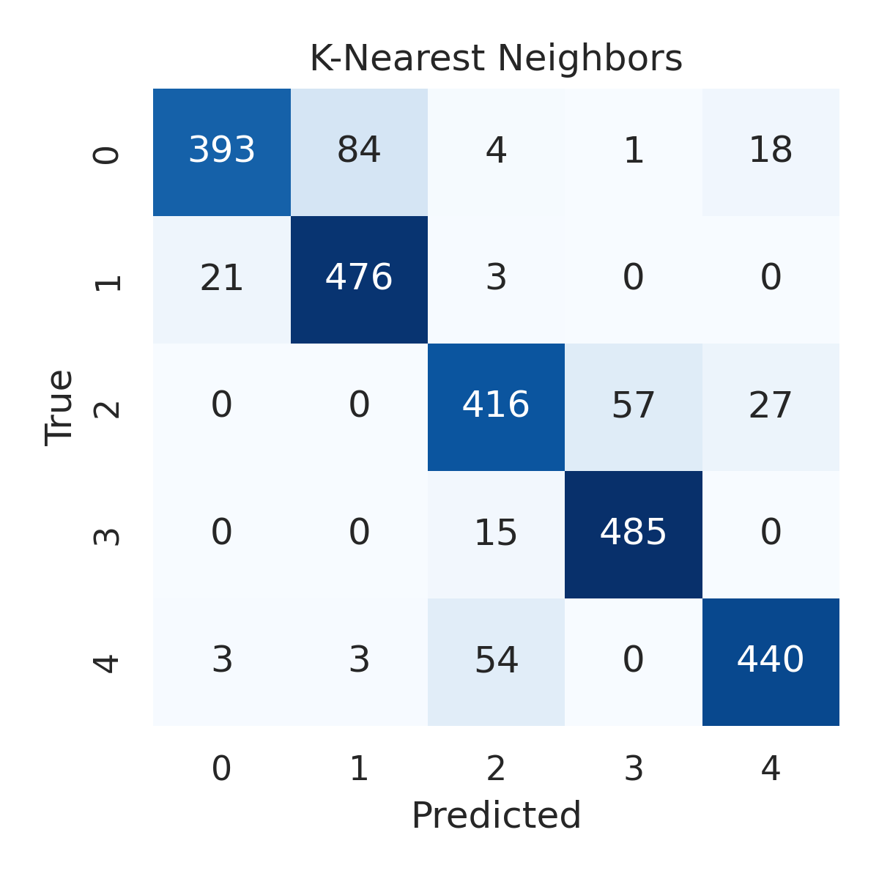

Combined ROC Curves
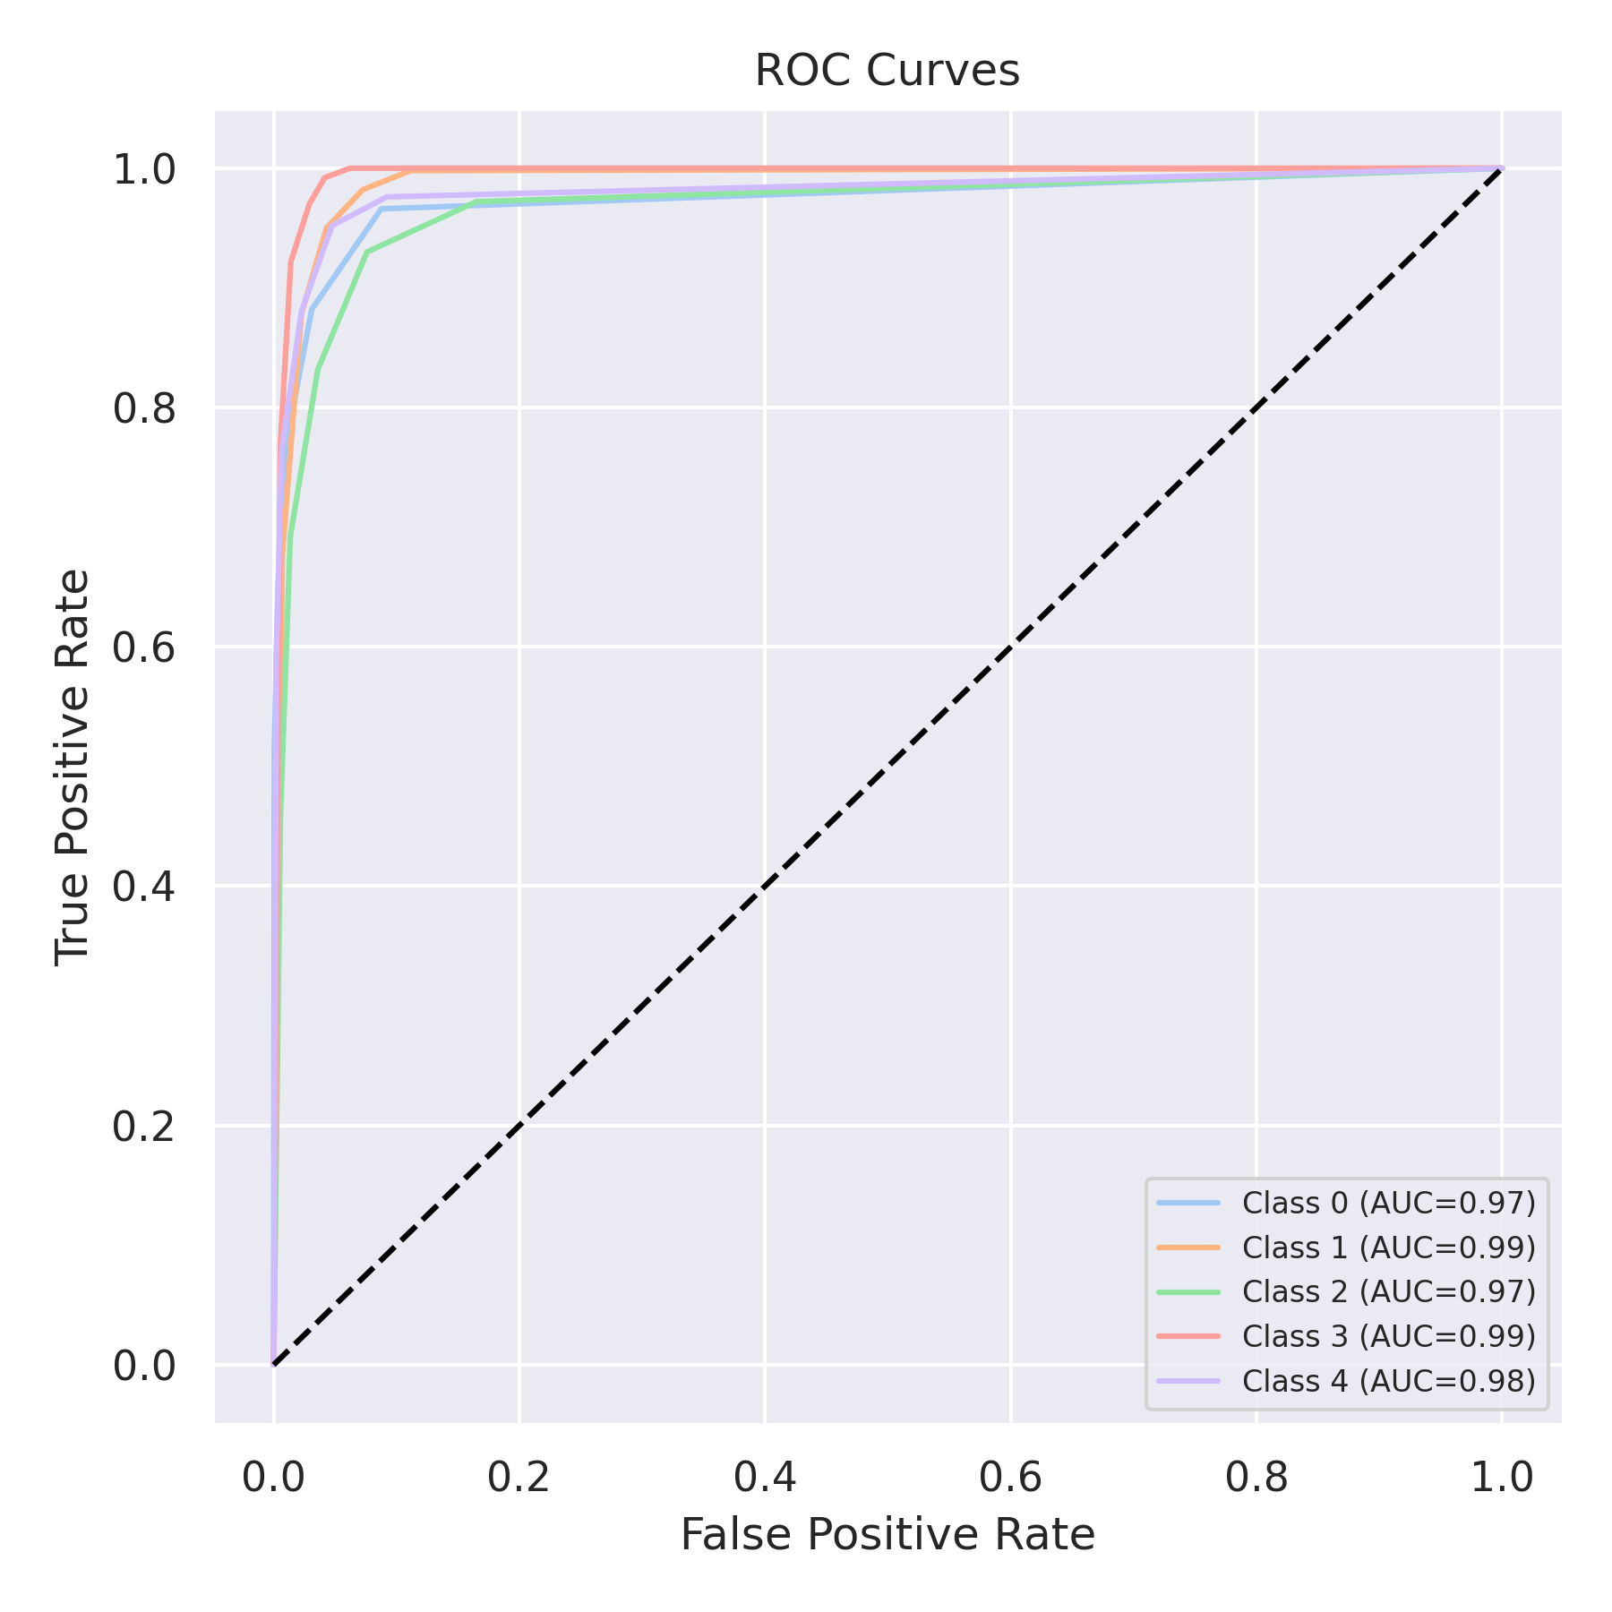

Evaluation: Decision Tree
Accuracy: 0.9664
Precision: 0.9663572818367451
Recall: 0.9664
F1 Score: 0.9663051583028326
Jaccard Index: 0.9352759183151999
Matthews CorrCoef: 0.9580364060751594
Cohen’s Kappa: 0.958
Specificity: 0.9916
AUC: 0.97
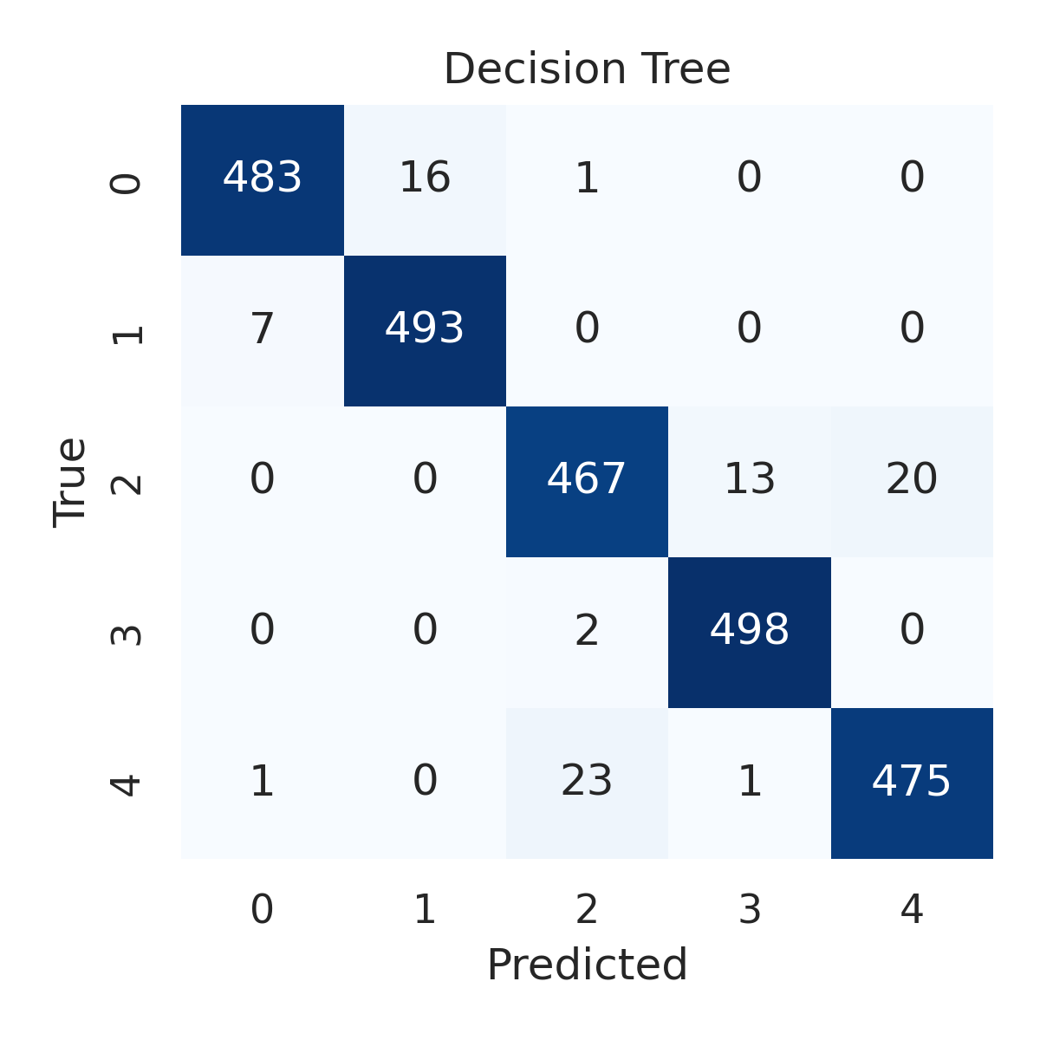

Combined ROC Curves
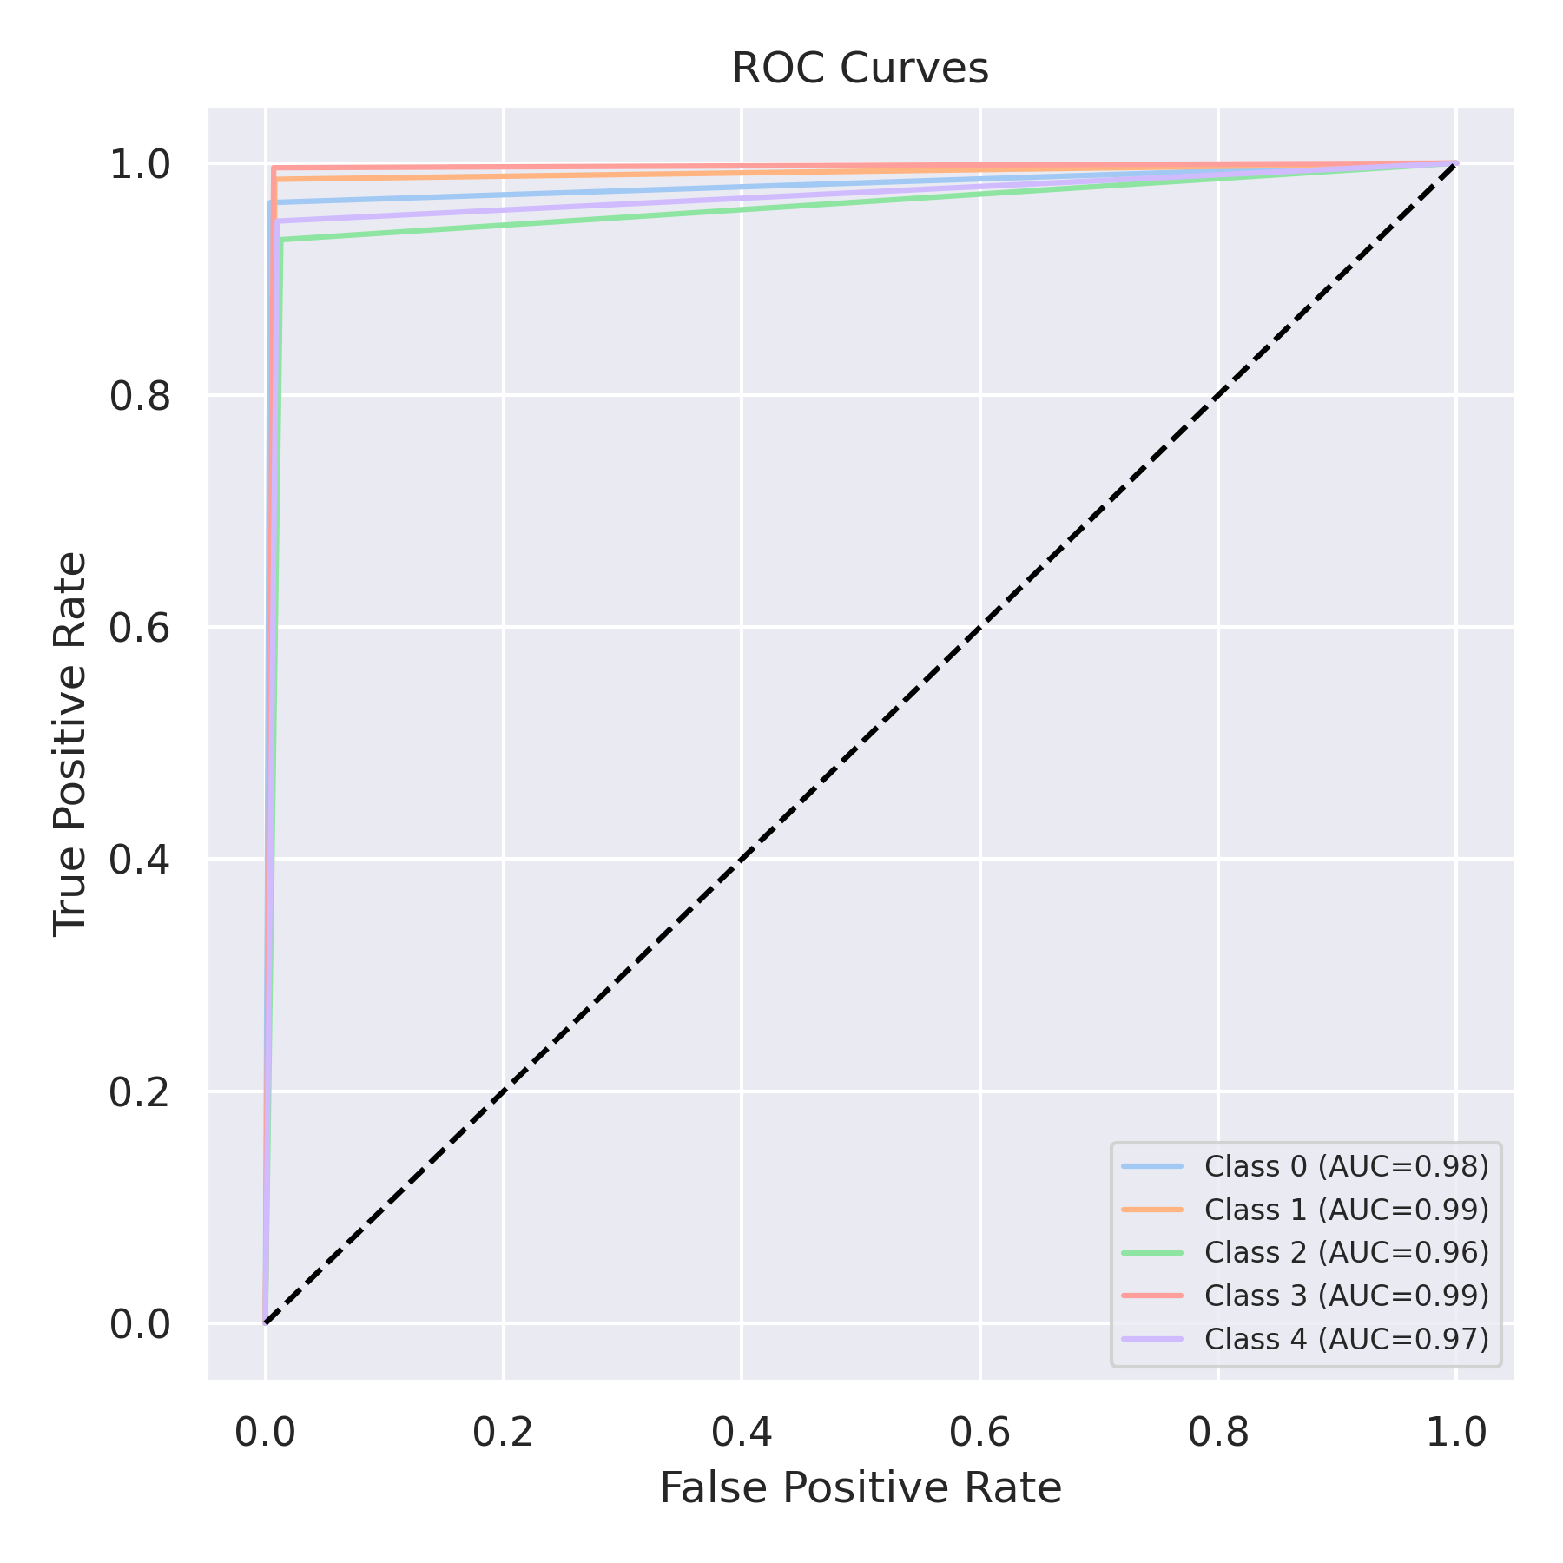

Evaluation: Extra Trees
Accuracy: 0.9692
Precision: 0.9692161410564466
Recall: 0.9692
F1 Score: 0.969098659533915
Jaccard Index: 0.9402884589070795
Matthews CorrCoef: 0.9615544255207704
Cohen’s Kappa: 0.9615
Specificity: 0.9923000000000002
AUC: 0.9982095000000001
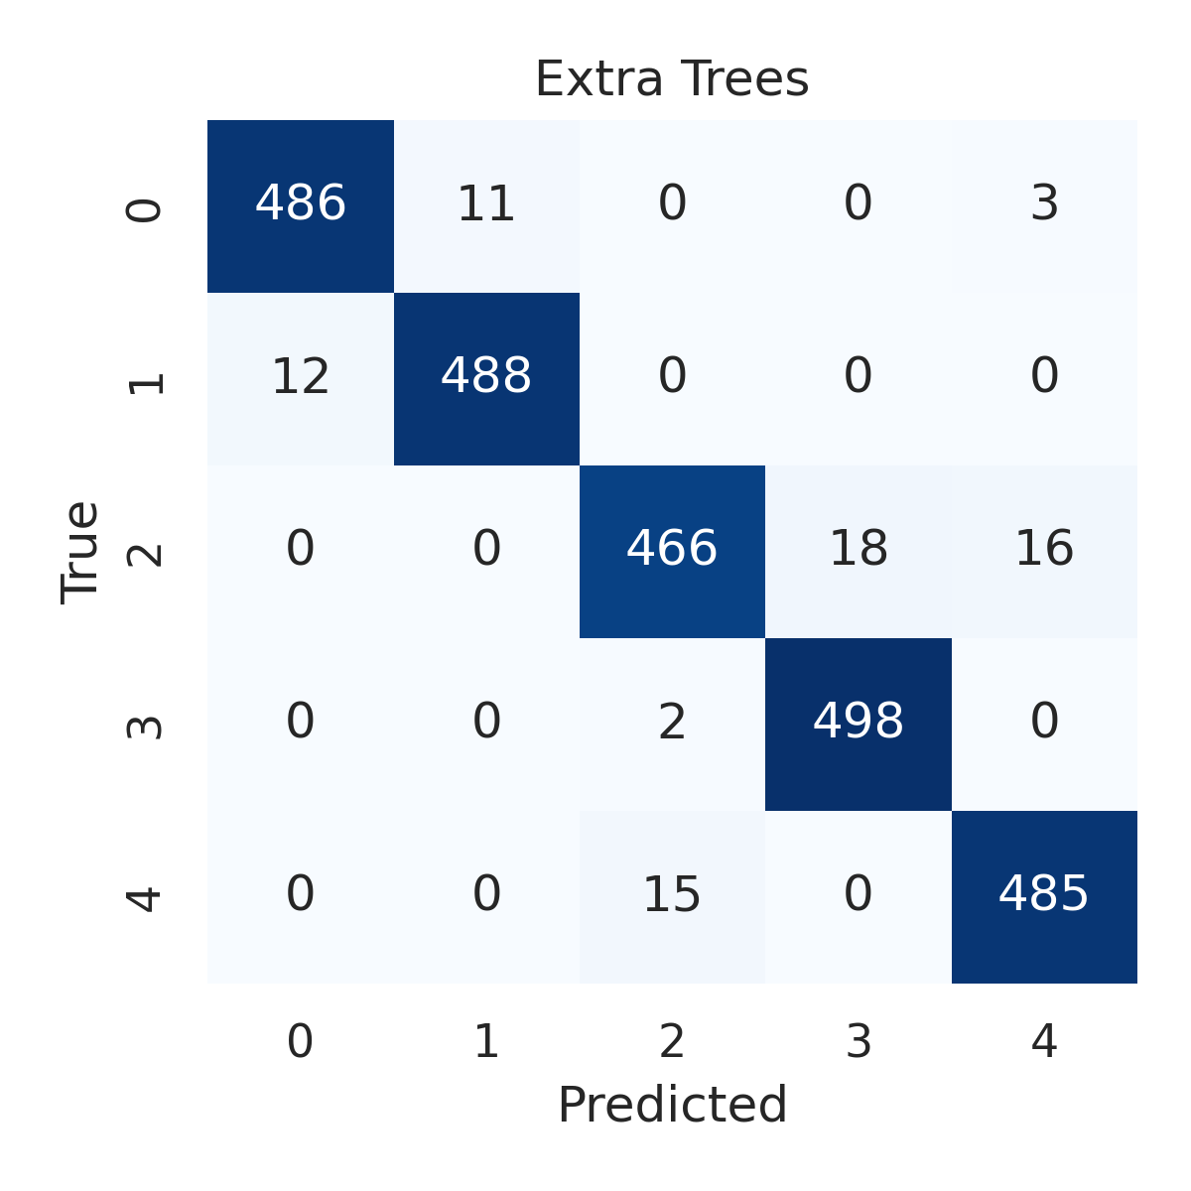

Combined ROC Curves
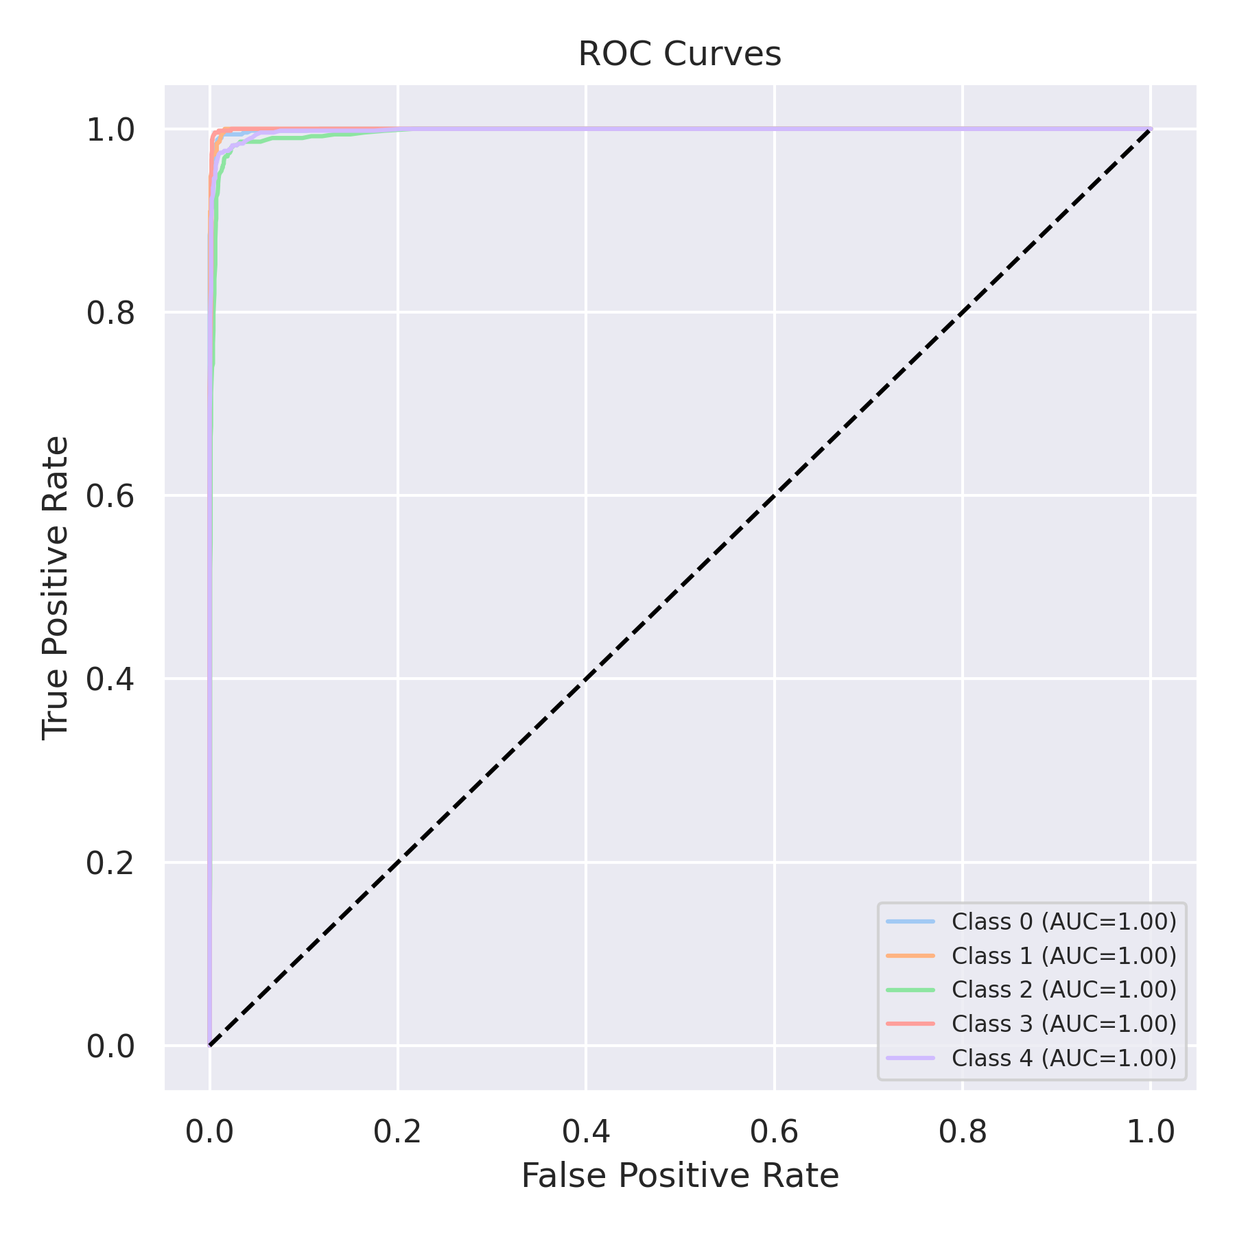

Evaluation: Bagging Classifier
Accuracy: 0.9748
Precision: 0.9747925378894537
Recall: 0.9748
F1 Score: 0.9747755620855904
Jaccard Index: 0.9509463696730851
Matthews CorrCoef: 0.9685102662632338
Cohen’s Kappa: 0.9685
Specificity: 0.9936999999999999
AUC: 0.994284
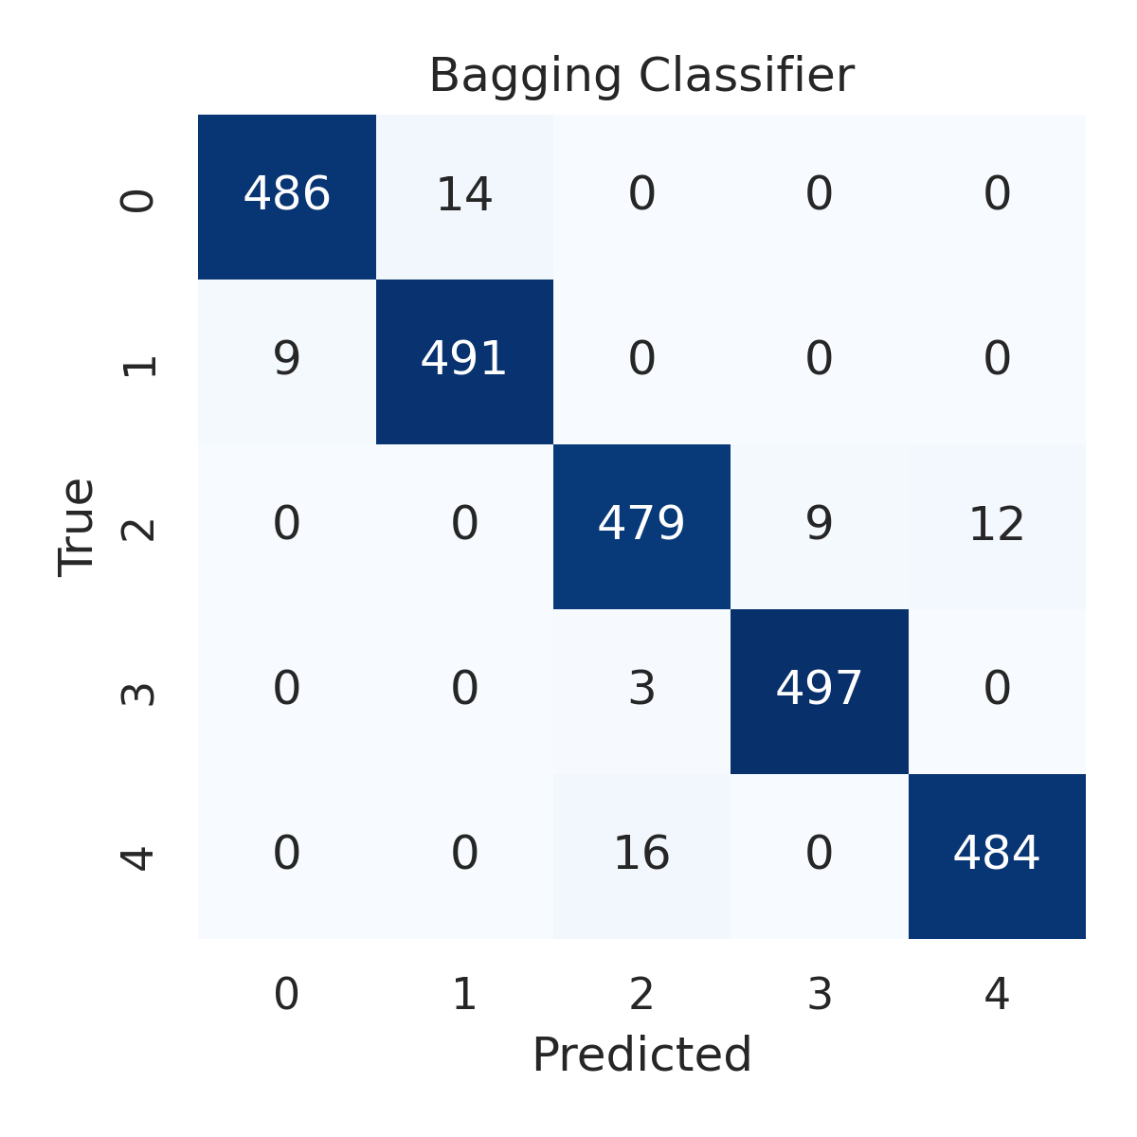

Combined ROC Curves
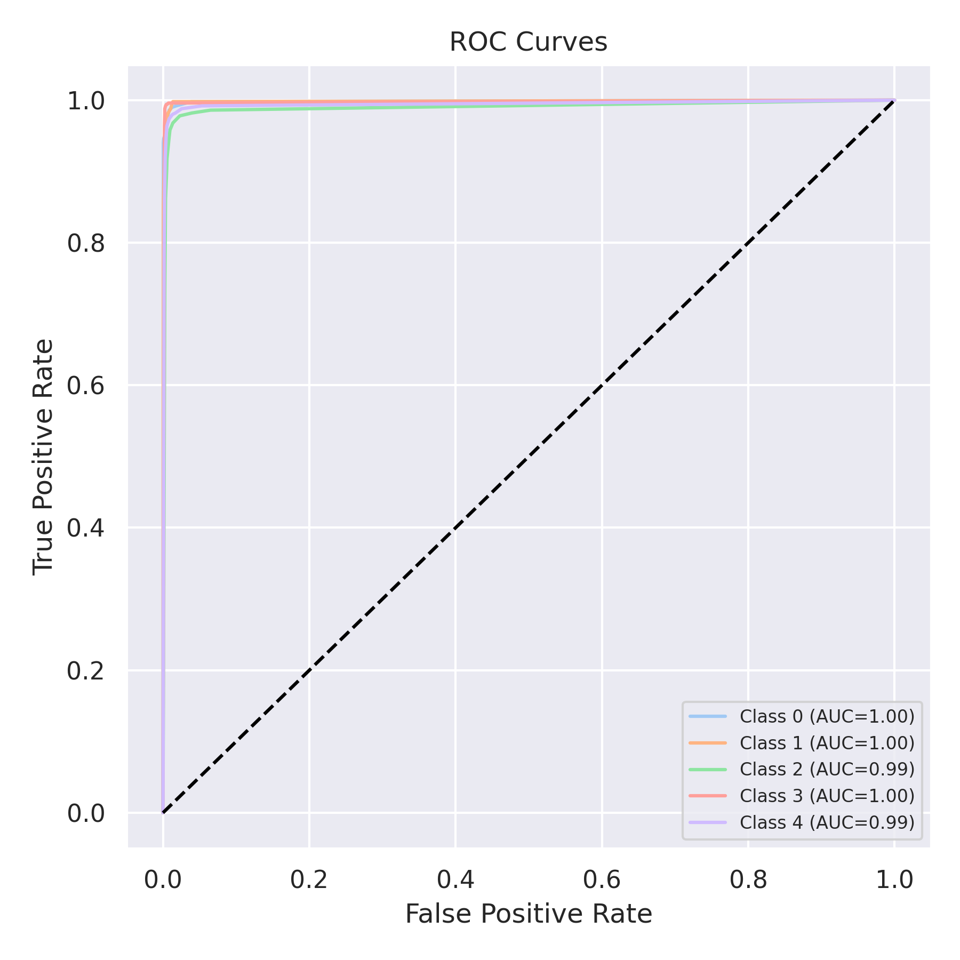

Evaluation: XGBoost
Accuracy: 0.9812
Precision: 0.9812157375499226
Recall: 0.9812
F1 Score: 0.9811885404151862
Jaccard Index: 0.9632298313997608
Matthews CorrCoef: 0.9765095698406769
Cohen’s Kappa: 0.9765
Specificity: 0.9953
AUC: 0.998783
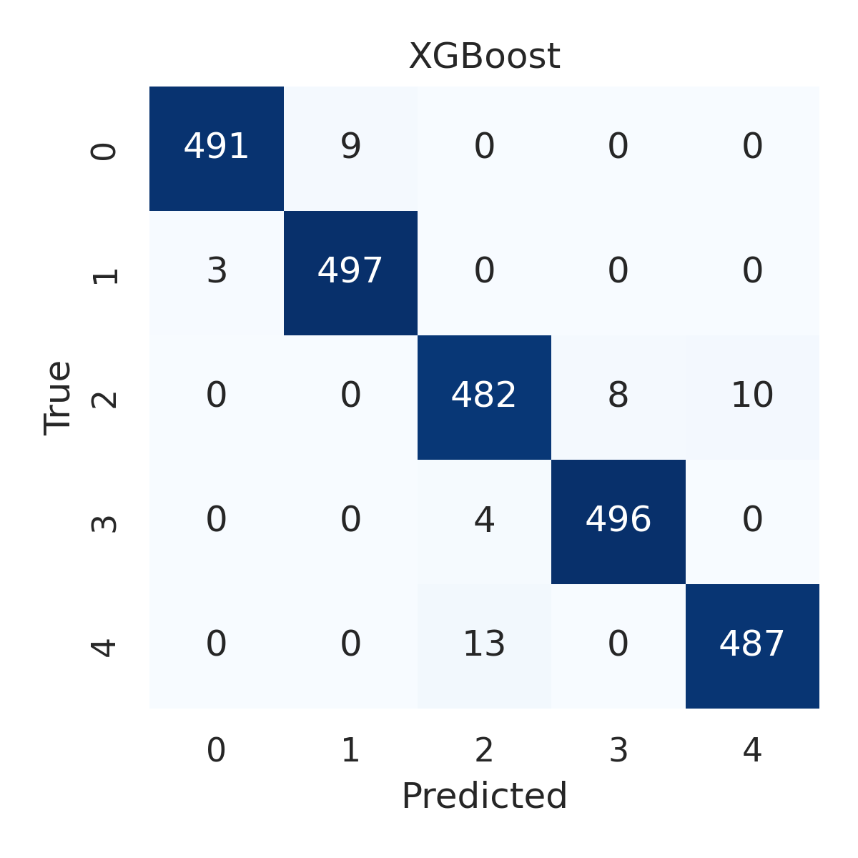

Combined ROC Curves
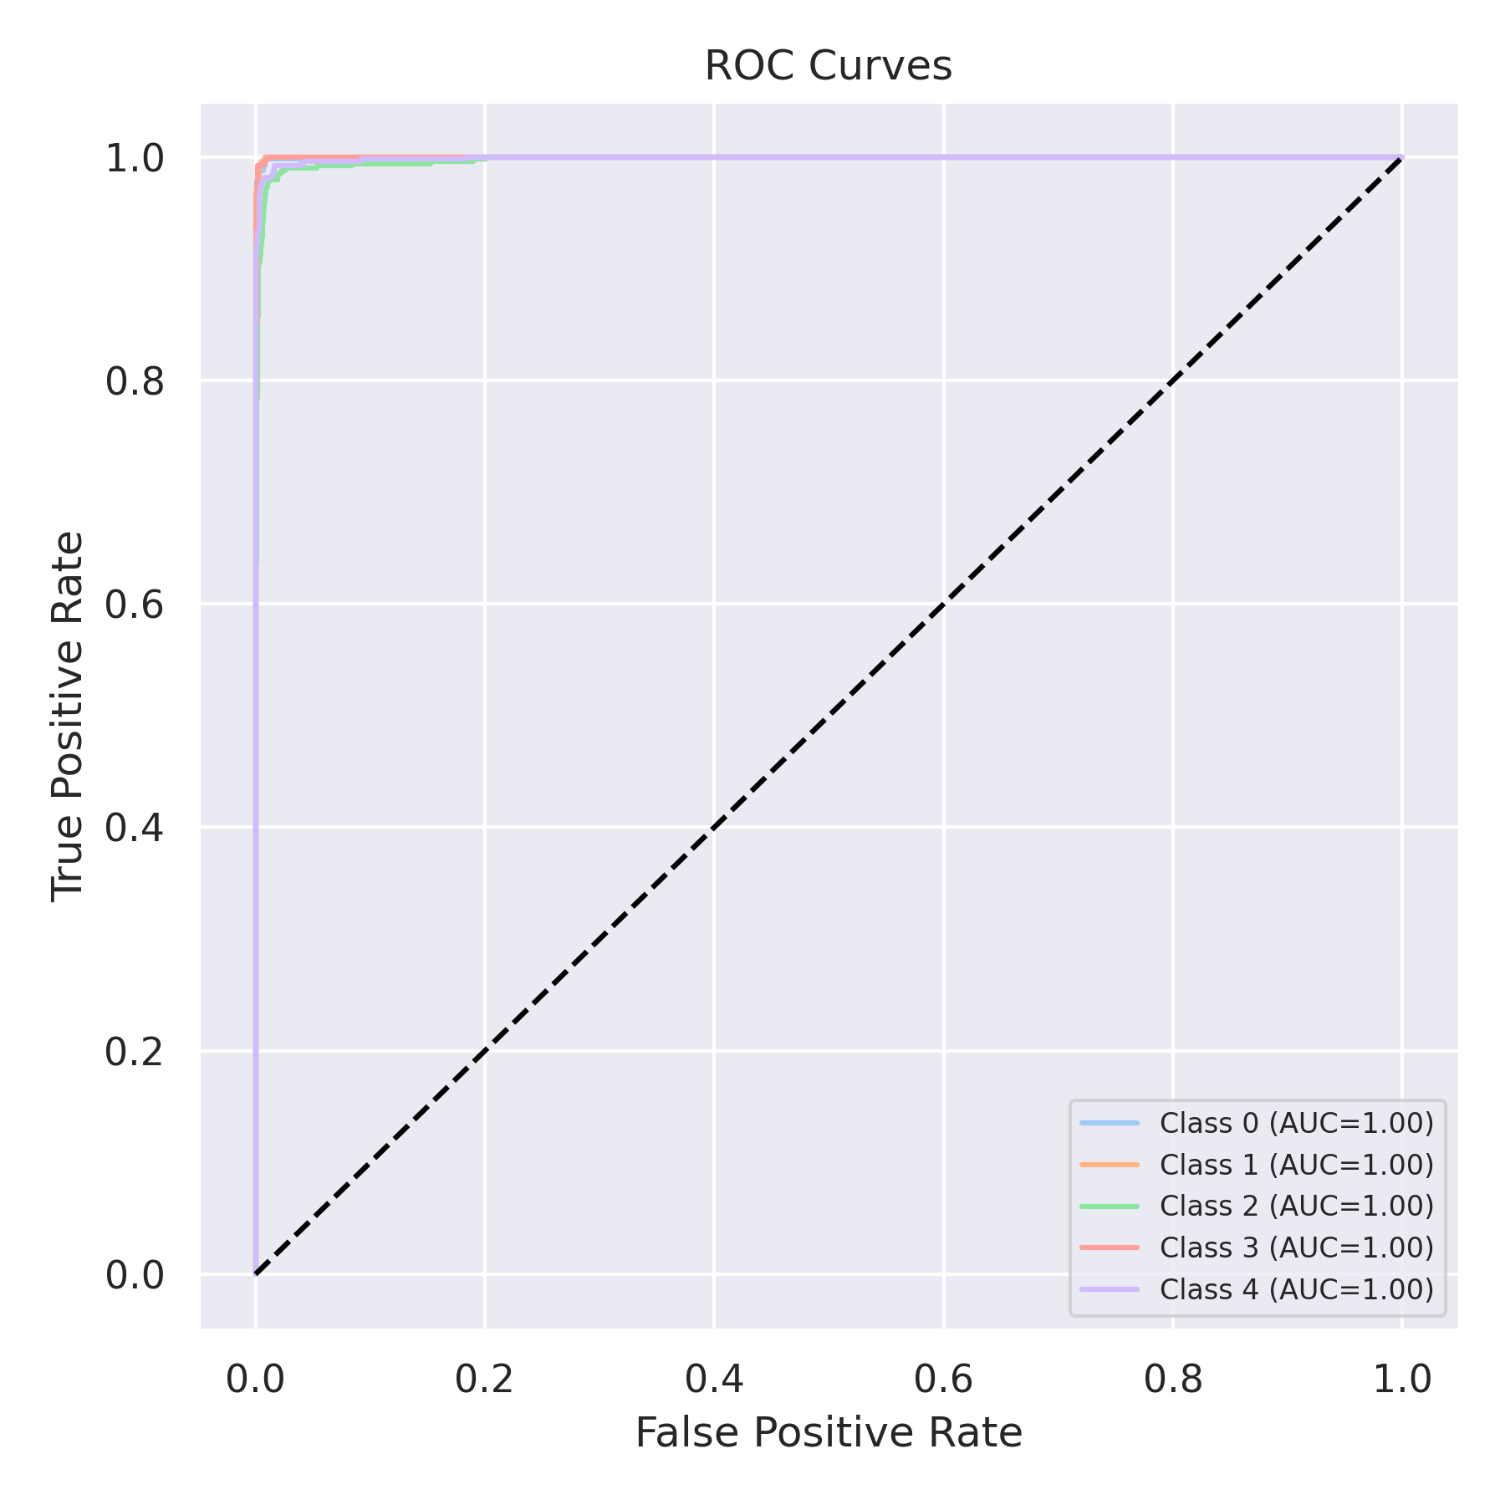

Evaluation: LightGBM
Accuracy: 0.9836
Precision: 0.98363327408922
Recall: 0.9836
F1 Score: 0.9835956893034289
Jaccard Index: 0.9678333073799429
Matthews CorrCoef: 0.9795103828650878
Cohen’s Kappa: 0.9795
Specificity: 0.9959
AUC: 0.9986100000000001
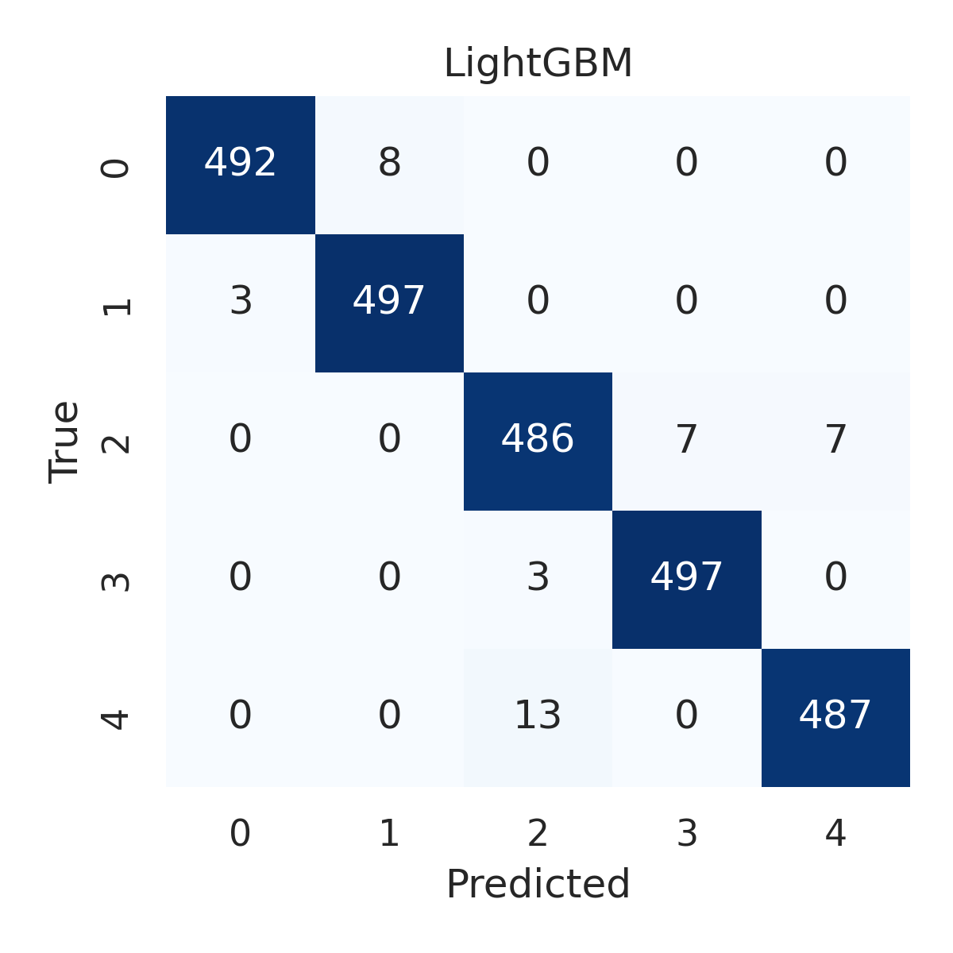

Combined ROC Curves
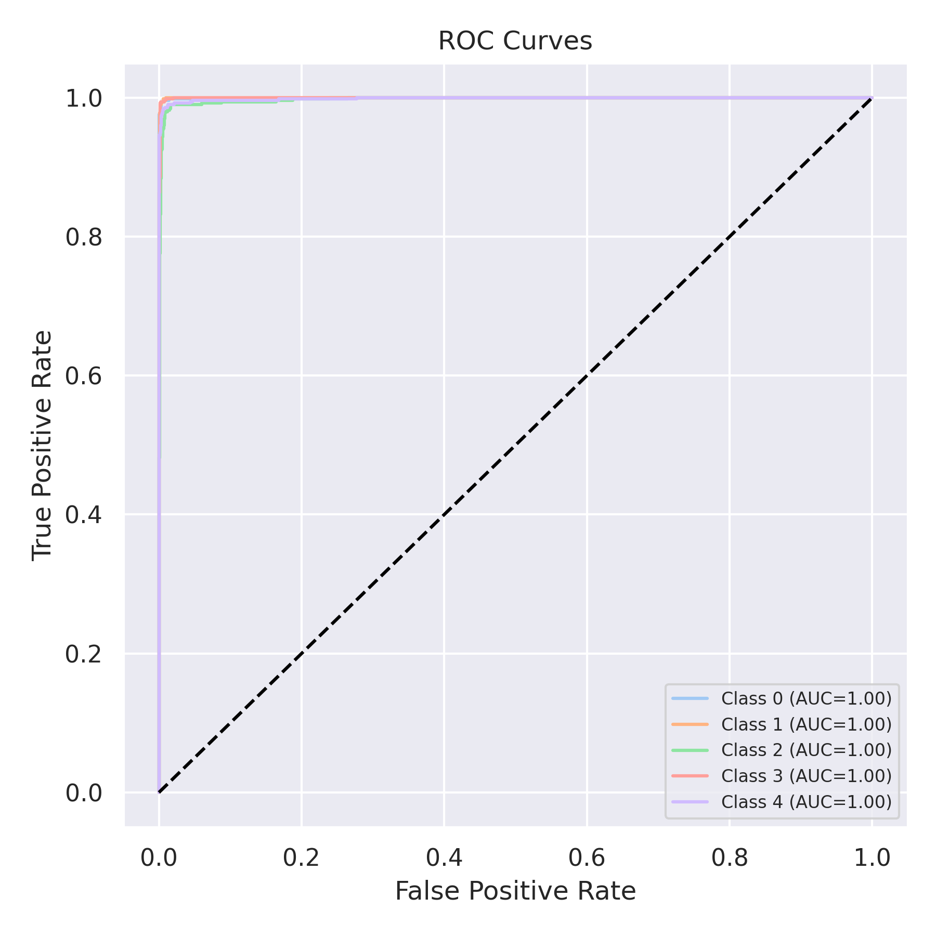

Evaluation: CatBoost
Accuracy: 0.2
Precision: 0.04
Recall: 0.2
F1 Score: 0.06666666666666667
Jaccard Index: 0.04
Matthews CorrCoef: 0.0
Cohen’s Kappa: 0.0
Specificity: 0.8
AUC: 0.9990479999999999
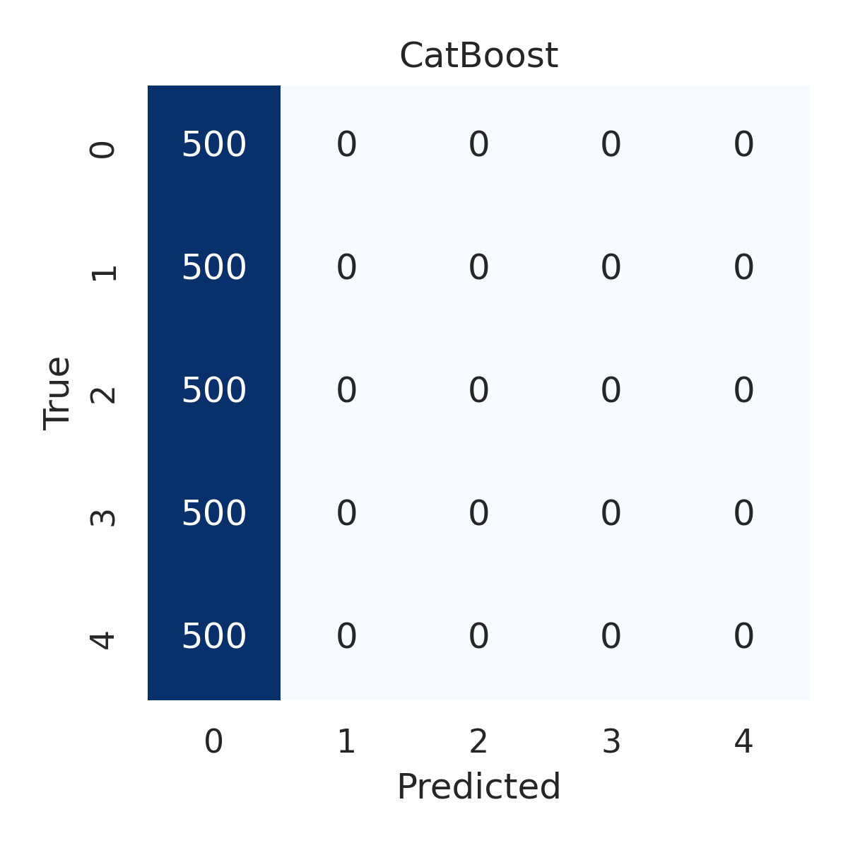

Combined ROC Curves
